Risk Management in UNI-PHARMA S.A.

Current practices and future developments

Preamble
This memo hereby summarizes all the approaches in our organization that demonstrate clearly that Risk management is deployed over a wide range of functions and is effectively built in our mode of operation and conduct of business, regardless of whether such Risk management modalities are explicitly described in the SOPs of our integrated Quality Management System or not.

Top Down Continuity
First of all, it is important to highlight that this organization has a moderate risk appetite with regards to market risk, built into its strategy and culture, while it’s entirely risk-avert when it comes to safeguarding its IP in partnerships and any kind of collaboration with external stakeholders, or any type of one-sided risks in terms of operational safety and efficacy.
This overall Risk approach is diffused vertically in the entire organizational and operational structure in a top-down fashion from Strategic Planning all the way down to Equipment Maintenance or Credit rating of wholesalers.
First of all, UNI-PHARMA’s strategy has been consistent throughout all years of its operation in the pursuit of a low margin- high volume portfolio of products with extended life-cycles. This strategy allowed the company to hedge against the variability in pricing and more specifically the pressure deriving from budget restraints on healthcare spending all across Europe through any period of fiscal consolidation.
Integrated Risk management approaches are evident in all functions from Inbound Logistics to Marketing & Sales, when we are focusing on the Value Chain and from Financial Management to HR, when we regard Key Supporting Activities.

Strategic Planning
Strategic planning follows PDCA cycles of planning, deployment, appraisal and adjustment (new planning):

Figure 1: Planning & review framework
The Planning and Deployment is captured in the current Business Plan, while appraisal is performed by monitoring KPIs, with the Annual Performance Review being the cornerstone of performance evaluation. In the Planning function, evaluation of the business macro/ micro economic and sociopolitical environment is the starting point. Rigorous Risk Management is performed by means of the following analytical frameworks:

PESTLE Analysis
Political:  Current and future governments shall need to adhere to further fiscal consolidation initiatives.  Fiscal consolidation and austerity shall prevail in the EEA in at least a 5-year horizon | Economic:  EU economy appears to experience further quantitative easing short to mid-term, but it’s unlikely that this will roll over to health and more particularly Pharma expenditures.  Reimbursement budgets shall continue to be tight  Liquidity drain all around EU  Disposable income of consumers shrinks- fierce competition for share-of-pocket in consumer healthcare products (OTCs, medical devices, etc.)
How does this affect us?  We need to anticipate further price reductions, claw-backs, rebates in the Greek market and focus in emerging/ developing markets for growth | How does this affect us?  Be careful when planning to launch mid-high margin products in terms of COGS, overall cost rationalization, invest in cost-efficiency, maintain our focus on low margin-high volume products, improve cash cycles, tighter credit policies, manage credit exposure in the supply chain, anticipate harder competition in the consumer healthcare segment
Social:  Patients/ consumers, the public, share views through social media with high speed and perceptions are formulated in those social networks | Technological:  Market Intelligence platforms are available and offer high level of information consolidation  Further automation and efficiency in manufacturing equipment  Enterprise Content Management systems are being upgraded
How does this affect us?  public image in social networks must be managed, optimized and uncontrolled exposure mitigated | How does this affect us?  We can utilize such tools/ platforms in order to make the decision processes more efficient and effective.  Improve manufacturing efficiency/ increase output-lower costs  Improve office productivity, efficient documentation
Legal:  EU framework remains relatively stable- however cGMPs become more stringent as well as the requirements for dossier development | Environmental:  EHS regulatory requirements become more stringent, while there is also higher social awareness which needs to be met with proactive initiatives beyond statutory obligations.
How does this affect us?  Longer product & dossier development times, more capital intensive | How does this affect us?  Increase in cost due to higher demands in resource deployment in order to satisfy the more stringent regulation and public expectations

PORTER FIVE FORCES OF COMPETITION FRAMEWORK

Threat of Entry of New Competitors | Low when considering vertically integrated structures trying to compete to a wide spectrum of the value chain due to high Initial Investment costs;  High when considering specialized high value added services (value chain fragmentation)
Bargaining Power of Suppliers | High volatility- increasing number of low cast alternative drives cost down but quality is always a concern.  IP clearance is also of high importance
Bargaining Power of Buyers | Increases due to easier access to digital information, social media networking and higher standards of living
Competition from Substitutes | Low due to the specific characteristics of the products and the industry. However, Product Life Cycle approaches are of the essence
Rivalry of established Competitors | High due to a still big number of existing companies, despite the ongoing, global, industry consolidation

SWOT Analysis

Business Model Analysis
The strategic planning is codified to Objectives and Approaches, which are in turn broken down to Long term, Mid-term and Short-term objectives. This is called the strategic thread and allows lineage between top level strategic directions and day-day to tasks.

UNI-PHARMA engages in all three major types of business models: Innovation, Manufacturing and Customer Service.

Figure 2: Types of Business Models & their Drivers
In order for a company to be successful by operating a mixed type business model it must identify the drivers behind each of the constituent business models and adapt the managerial priorities and objectives accordingly. However, business drivers that point towards opportunities bear by definition a significant amount of risk. Success comes from harnessing the opportunities presented while mitigating the down-side possibilities. Excellence in those business drivers becomes the source of competitive advantage. The attainment of the business driver objectives comes through the entire spectrum of enterprise operations. In order to be able to segment and focus, business functions are mapped in accordance to the M. Porter Value Chain Analysis:
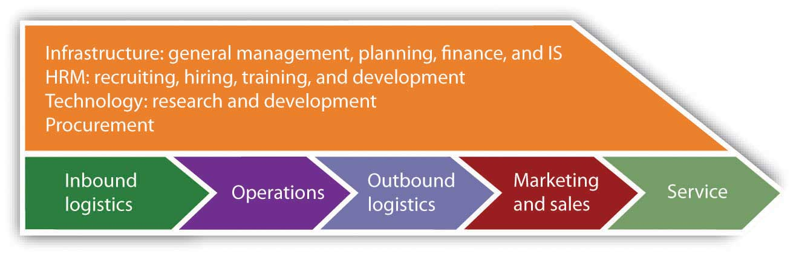

Figure 3: Strategic thread x Business model types 2D matrix

Stakeholder mapping

Another view that is critical to identifying Risks associated with the functions and business processes of the organization is that of its Stakeholders. Stakeholders are discerned to Internal and External; Internal are the Shareholders- Managers- Personnel, while the External are further segmented to Key Partners & Suppliers, Social Partners and Authorities & Regulators.

Key partners and suppliers
Key business partners are divided to those who precede UNI-PHARMA in the Value Chain or contribute to Value Added Processes of UNI-PHARMA, hence the Suppliers of Raw Materials or Technology - Providers of Science, Techniques, Business Services and Assigned Know-how, and those who follow down the Value Chain, thus Resellers either just wholesalers or distributors of marketers):

For all possible partnering models that the organization can get into with these Key Partners and Suppliers there are policies providing the context of collaboration.
Social Partners – Social Responsibility
With absolute commitment to the Balanced Scorecard, UNI-PHARMA follows its responsible Resource Management and develops actions to ensure sustainable business success by maximizing the benefits for the wider society. The main elements of the above systemic approach are the formulation of the primary CSR strategy and then the design and execution of an integrated action plan with objectives.

Risk Management Map
Existing Risk Management approaches per function and concerned stakeholder, as derived by all the above analyses, can be summarized in the table below:
Function | Approaches | Stakeholders | Risk MGMT
Supply Chain (inbound/outbound logistics, procurement, warehousing) | Logistics Policy, Procurement Policy, GDPs, Internal Logistics processes | Material Suppliers | Mitigating the possibility of ordering and or receiving OOS materials, mitigating the possibility of inadequate or excessive stock levels, mitigating the possibility of delivering wrong materials to production
Operations | GMPs, EHS | Internal Stakeholders- Personnel/ Management | The GMP protocols have Risk mitigation as a major objective in order to achieve Quality Standards and safeguard human life. Derivative to this is the mitigation of the cost of poor quality
Marketing & Sales | International Partnering Policy (basic terms, agreements), Wholesale Policy, Pharmacy sales Policy | Customers, Licensees | Mitigating market risk (selection of product mix, marketing mix), stock-outs or overstocking
CSR | Ethical Conduct, Environmental Management  Access to Treatment, Solidarity & Volunteerism | Society | Mitigating the risk of poor perception, or “corporate villainization”
Compliance | Regulatory Affairs, Legal Affairs (processes and policies) | Governmental Agencies, Regulatory Authorities | Mitigation of Legal and Administrative shortcomings that may result to penalization
R&D | IP Management, Knowledge Management | Customers, Licensees, Technology Providers/ Partners | Mitigating IP infringements, loss of competitive advantage, product related technical shortcomings (e.g. formulation, process flow steps, etc.)
HR | GDPR policy, EBEN, UN Global Compact, Recruiting Policy, Knowledge Management Policy | Internal Stakeholders- Personnel/ Management/ Shareholders | Mitigating high personnel turn-over risk, prolonged learning curves, rising training costs
MIS | Security, Business Continuity | All Internal & External Stakeholders we interact with electronically | Mitigating the risk of industrial espionage, breach of confidentiality, data loss
Financial Management | Cash Flow management, Management of Receivables, Credit scoring, Overall Financial Management | Customers, Financial Institution, Tax Authorities, Shareholders | Ensuring solvency, and long-term financial sustainability by achieving Return of capital employed, Return on investments and sustainable profitability
Manufacturing Equipment & Facility Management | Security, Business Continuity, Preventive Maintenance, SLAs | Internal Stakeholders- Personnel/ Management/ Shareholders | Mitigating the risk of industrial espionage, breach of the premises with criminal intent, productivity loss

Future Developments
Next steps are to deploy further Risk Management approaches in the SOPs of the organization and document them in a systemic way (Risk identification, Risk Measurement, Risk Mitigation).

